Browser and System Forensic Investigation using Autopsy:
Recover browser history, downloaded files, user activities, and system artifacts to investigate cyber incidents using Autopsy.
Practical: Browser and System Forensic Investigation Using Autopsy
Aim: To investigate browser history, downloaded files, user activities, and system artifacts using Autopsy, a digital forensics tool, to understand and investigate cyber incidents.
1. Requirements
- Computer or laptop running Windows.
- Autopsy digital forensics software installed.
- A forensic disk image or a sample dataset containing browser and system artifacts.
- Sample evidence files for investigation.
- Administrator privileges if required for accessing evidence.
Important: Perform this practical only on authorized lab systems and sample forensic evidence. Do not investigate another person's private data without permission.
2. Step-by-step procedure
Step 1: Open Autopsy
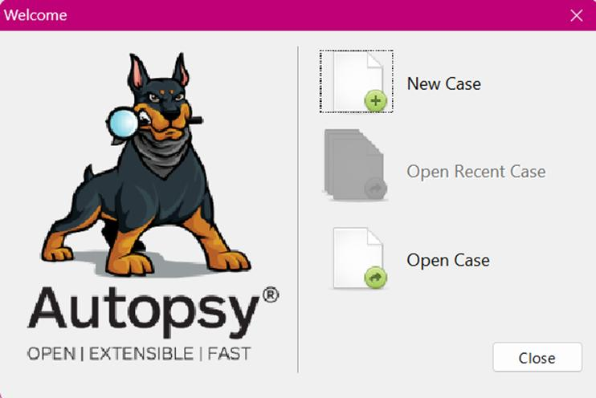
medium.com
- Start your computer.
- Open Autopsy from the Start menu.
- Wait for the application to load.
- Click New Case to create a new forensic investigation.
Step 2: Create a new case
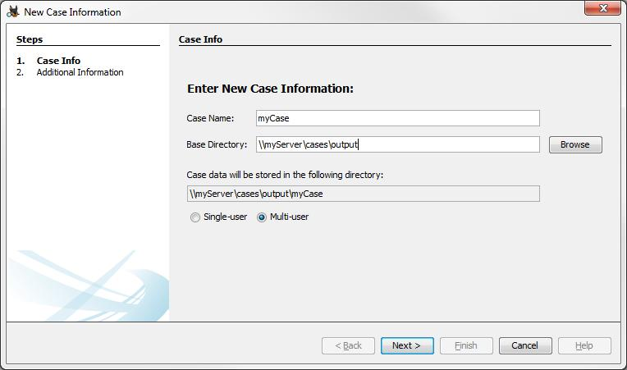
sleuthkit.org
- Enter the Case Name, for example, Browser_System_Forensics.
- Select a folder where the case data will be stored.
- Click Next.
- Enter the case details:
  - Case Number: CSF-IRM-001
  - Examiner: Student Name
  - Other details, if required.
- Click Finish.
Observation: A new forensic case is created to store the investigation results.
Step 3: Add the evidence source
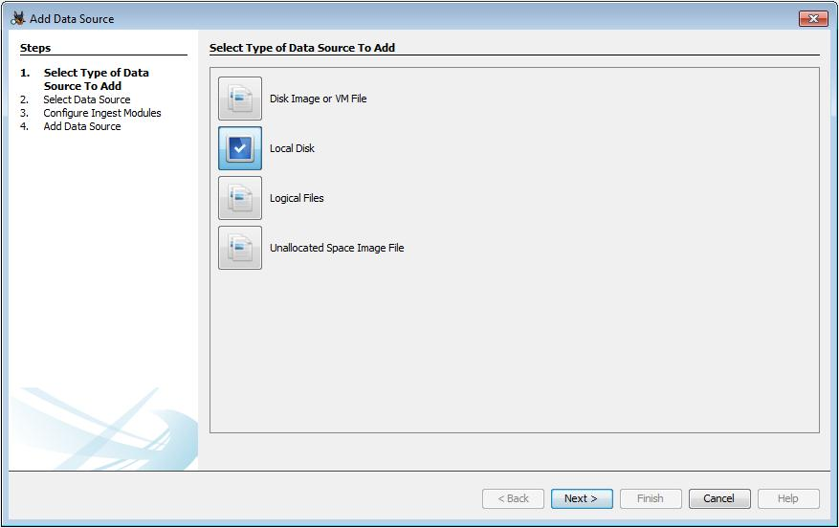
sleuthkit.org
- Click Add Data Source.
- Choose the appropriate source type:
  - Disk Image or VM File: To examine an existing forensic image, such as E01 or raw/DD.
  - Local Disk: To examine an authorized local drive.
  - Logical Files: To examine selected files or folders.
- Browse and select your instructor-provided forensic image or sample evidence.
- Enter the time zone if prompted.
- Click Next.
Recommendation: For a classroom exercise, use a prepared forensic disk image rather than collecting evidence from your personal computer.
Step 4: Select ingest modules
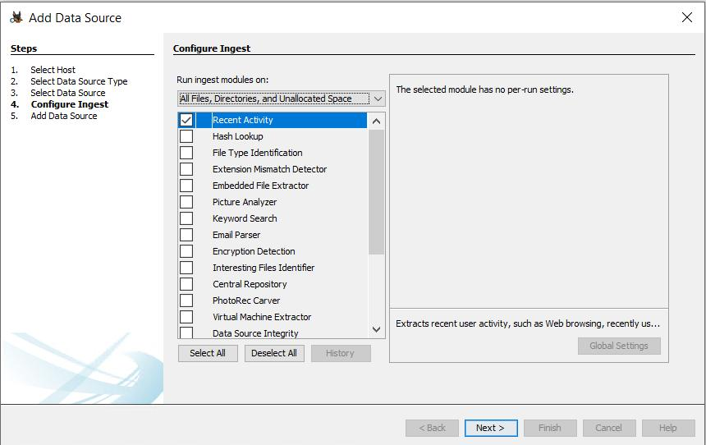
otuva.medium.com
Ingest modules automatically process the evidence and identify useful artifacts.
Select the available modules relevant to your investigation, such as:
- Recent Activity: Examines supported browser and operating-system activity.
- Web Artifacts: Extracts supported web history, downloads, cookies, and related browser artifacts.
- File Type Identification: Identifies files based on their content.
- Hash Lookup: Checks file hashes against configured hash databases, if available.
- Interesting Files Identifier: Flags files matching configured criteria.
Module names and availability can vary by Autopsy version.
Click Next or Finish to start processing, depending on the version.
Step 5: Wait for evidence processing
- Allow Autopsy to process the evidence source.
- Monitor the ingest progress.
- Wait until the relevant processing tasks are complete.
- Review any processing errors or warnings.
Observation: Autopsy creates an indexed view of the evidence and extracts supported forensic artifacts.
Step 6: Examine browser history
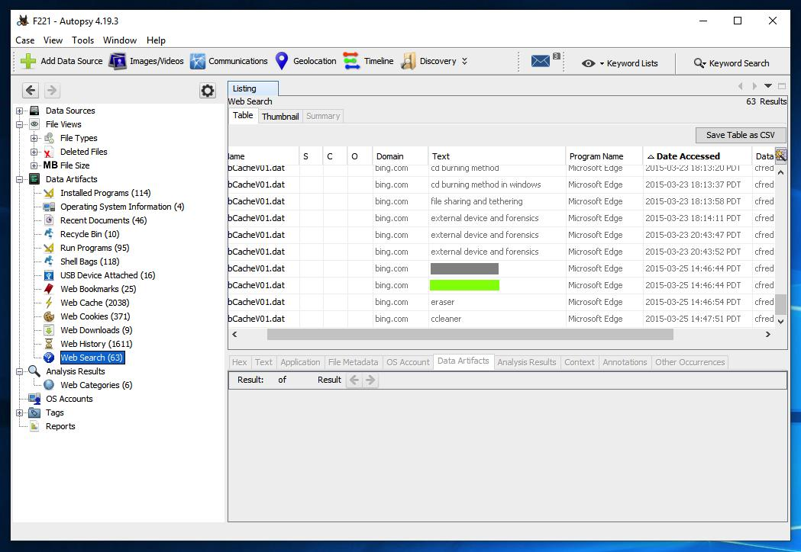
samsclass.info
- In the left navigation panel, expand Data Artifacts.
- Look for Web History or the equivalent browser-history category.
- Select the category to view the extracted records.
- Examine the available fields:
  - URL visited.
  - Page title.
  - Visit date and time.
  - Browser information, if available.
- Record suspicious or relevant URLs and their timestamps.
Example observation: A browser history entry may show that a user visited a suspicious website shortly before a reported security incident.
Note: Browser history may be missing if it was deleted, not included in the evidence, or not supported by the selected data source.
Step 7: Examine downloaded files
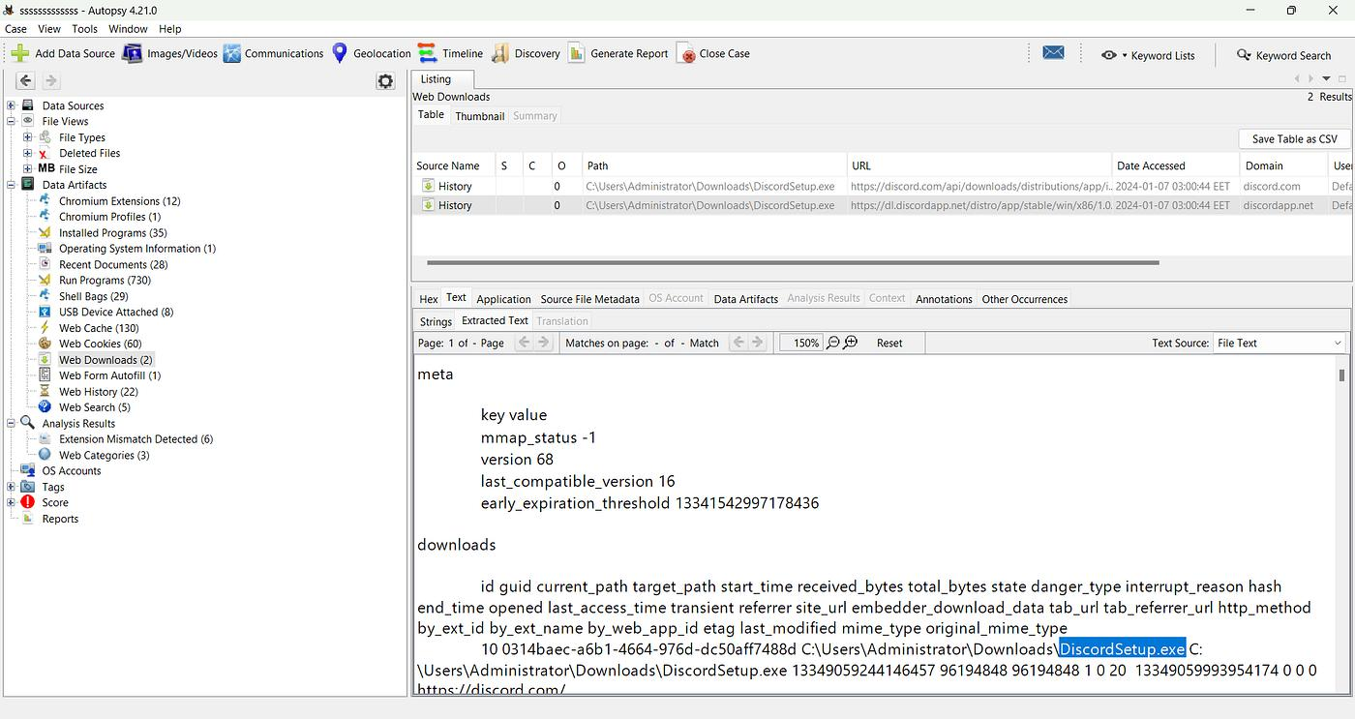
medium.com
- Expand Data Artifacts and look for Web Downloads, if available.
- Review the extracted download records.
- Note:
  - Downloaded filename.
  - Source URL, if recorded.
  - Download timestamp, if available.
  - File location or path.
- Next, examine the file listing under File Views or the relevant directory tree.
- Locate the Downloads folder and inspect associated files.
- Review file metadata and hashes when available.
Important: A download record and the actual downloaded file are different forms of evidence. One may exist even when the other is unavailable.
Step 8: Investigate user activity
- Expand Data Artifacts.
- Examine relevant categories, such as:
  - Web Search, if supported.
  - Recent Documents.
  - Recent Activity.
  - Operating-system login or execution artifacts, when present.
- Review timestamps and associated file paths.
- Correlate browser activity with other available system artifacts.
For example, a browser download followed by evidence that a related file was accessed may provide a useful investigative lead.
Caution: An artifact alone does not prove who performed an activity. Shared accounts, automated processes, and incorrect system clocks can affect interpretation.
Step 9: Examine system artifacts
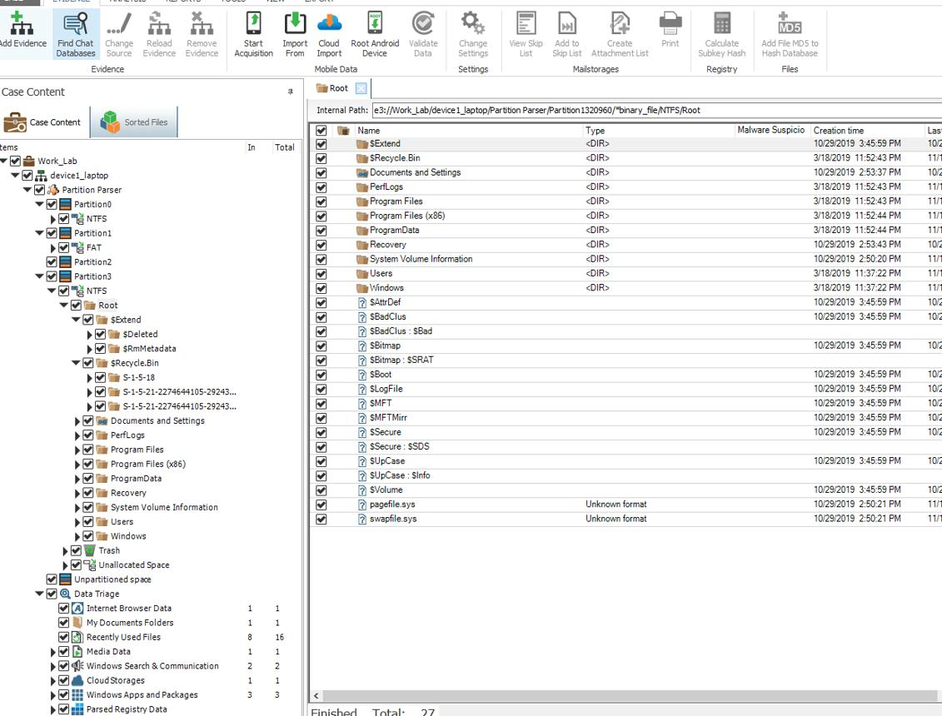
sleuthkit.discourse.group
- Expand File Views.
- Browse the file-system hierarchy.
- Examine relevant user directories, application data, and system files present in the evidence.
- Check file metadata, including:
  - File name and path.
  - File size.
  - File type.
  - Available timestamps.
  - Hash values, if calculated.
- Look for relevant files such as browser databases, suspicious executables, or recently accessed documents.
Do not interpret a file's timestamp as conclusive proof of when a person used it. Different timestamp types have different meanings.
Step 10: Correlate the evidence
Create a timeline from the artifacts collected during the investigation.
Time | Artifact | Observation
09:10 AM | Browser history | Website visited
09:15 AM | Web download record | File download recorded
09:18 AM | File metadata | Related file found
09:25 AM | System artifact | Additional activity identified
The times and events above are illustrative examples, not actual findings.
- Compare browser history with download records.
- Check whether related files exist in the evidence.
- Compare timestamps across artifacts.
- Identify inconsistencies and possible explanations.
- Record findings without making unsupported conclusions.
Step 11: Generate the forensic report
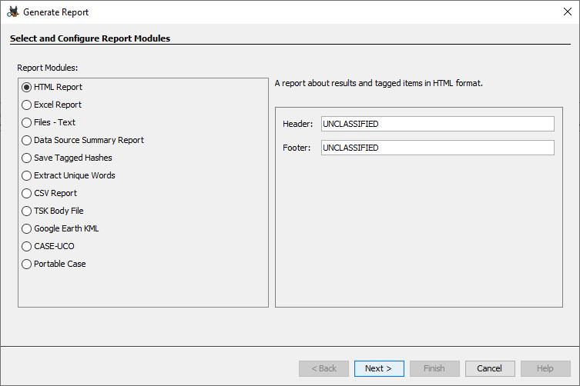
sleuthkit.org
- Open the Generate Report option in Autopsy.
- Select a suitable report module, such as an HTML report, if available.
- Choose the relevant artifact categories or results.
- Generate the report.
- Save it in the designated lab output folder.
- Verify that the report contains the selected findings and relevant metadata.
Preserve the original evidence and document the evidence source, acquisition details, hash values where available, and any limitations encountered.
3. Observation table for the practical record
Fill this table using the actual results from your lab exercise.
Sr. No. | Artifact examined | Observation to record
1 | Browser history | URLs and visit timestamps found
2 | Web downloads | Download names and source details
3 | User activity | Relevant activity artifacts found
4 | System files | File paths, metadata, and hashes
5 | Timeline | Correlated events and timestamps
6 | Forensic report | Report generated and verified
4. Result
Browser and system forensic investigation was performed using Autopsy. The available evidence was examined to identify browser history, downloaded files, user activity records, and system artifacts. The findings were correlated and documented in a forensic report.
5. Viva questions
- What is digital forensics?
- What is Autopsy?
- What is a forensic disk image?
- What information can browser history provide?
- What is the difference between web history and web downloads?
- What is an ingest module in Autopsy?
- Why are file hashes used in digital forensics?
- What is the importance of timestamps in an investigation?
- Why should original evidence be preserved?
- Can browser history alone prove that a particular person visited a website? Explain.

